#### HANDS Workshop

**HANDS Workshop: Traditional Crafts Applications in Architecture and Interior Design Projects**

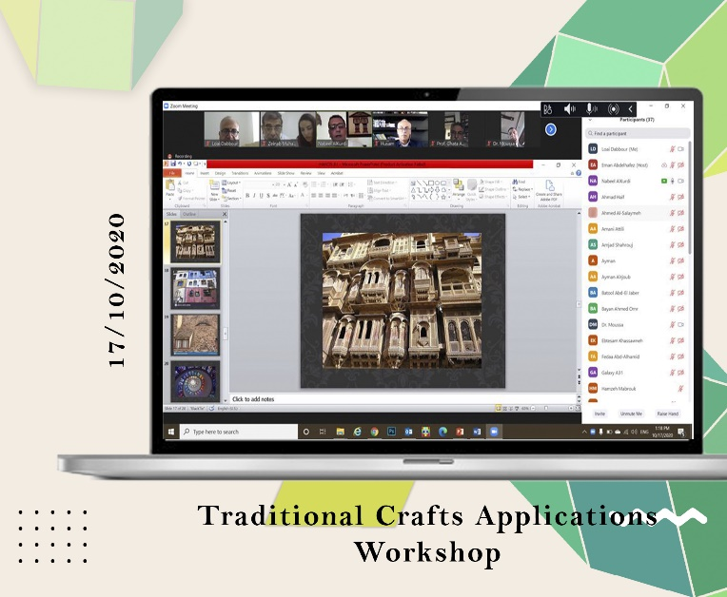**WP 6: DEVELOPMENT**

**Date:** Saturday, 17/10/2020  
**Organizer:** Al-Zaytoonah University of Jordan (ZUJ)  
**Location:** Online via ZOOM

Organized by ZUJ, this workshop with the project advisory board, Jordanian, and Syrian partners aims to leverage their knowledge for the HANDS project. It begins with a welcome speech and overview by the project coordinator, followed by advisory board members sharing case studies and Jordanian craft specialists presenting. The workshop promotes collaboration and knowledge exchange for project advancement.

Top of Form